DNS Zone

🌍 What is a DNS Zone?
# Source: Chatgpt (GPT-5-Mini) at [1/18/2026]
A DNS zone is a portion of the Domain Name System (DNS) namespace that is managed by a specific organization or administrator and contains DNS records for one or more domains.
🧠 Think of a DNS zone as a configuration file or container that holds all the DNS records for a domain and its subdomains.

🔍 Key Features of a DNS Zone
# Source: Chatgpt (GPT-5-Mini) at [1/18/2026]
- Defines control: A zone defines who is responsible for managing DNS settings for a domain.
- Contains records: A zone includes resource records like A, AAAA, MX, CNAME, TXT, NS, SOA, etc.
- Managed via zone file: Typically stored in a zone file on a DNS server.
- Starts with an SOA record: Every zone begins with a Start of Authority (SOA) record.
- Delegation possible: A zone can delegate authority to subzones (e.g., blog.example.com).

🧱 Structure of a DNS Zone
# Source: Chatgpt (GPT-5-Mini) at [1/18/2026]
A DNS zone might include:
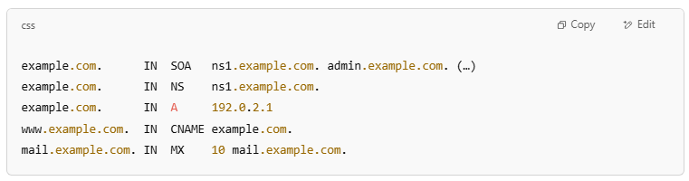
example.com. IN SOA ns1.example.com. admin.example.com. (…)
example.com. IN NS ns1.example.com.
example.com. IN A 192.0.2.1
www.example.com. IN CNAME example.com.
mail.example.com. IN MX 10 mail.example.com.

🗂️ Types of DNS Zones
# Source: Chatgpt (GPT-5-Mini) at [1/18/2026]

Zone Type | Description
Primary (Master) | Holds the original zone file and is editable
Secondary (Slave) | A read-only copy of the zone from a primary server
Reverse Zone | Used for reverse DNS lookups (IP → domain)

DNS zone file

📄 What is a DNS Zone File?
# Source: Chatgpt (GPT-5-Mini) at [1/18/2026]
A DNS zone file is a text file that contains the DNS records for a specific domain (DNS zone). It tells DNS servers how to resolve domain names to IP addresses and other resources.
🧠 Think of it as the blueprint for a domain’s DNS settings — defining how that domain behaves on the internet.

🔍 What’s Inside a Zone File?
# Source: Chatgpt (GPT-5-Mini) at [1/18/2026]
A zone file contains resource records (RRs), each on a new line, with data like:
- The domain/subdomain name
- The record type (e.g., A, MX, CNAME, etc.)
- The value (like an IP address or another domain)
- TTL (Time To Live) and other metadata

🧱 Example DNS Zone File for example.com
# Source: Chatgpt (GPT-5-Mini) at [1/18/2026]
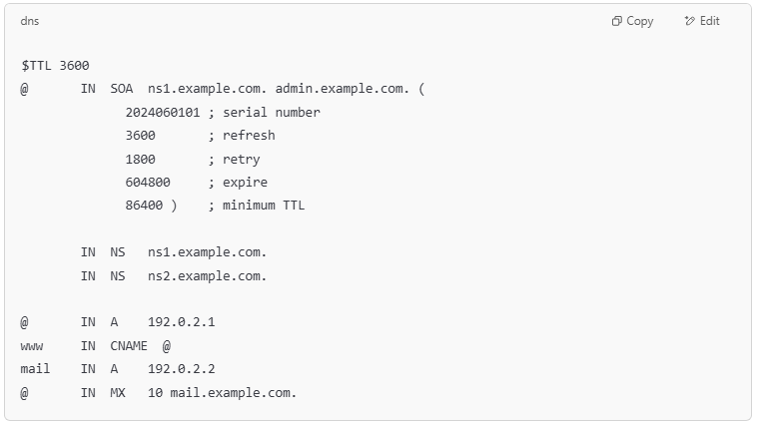
$TTL 3600
@ IN SOA ns1.example.com. admin.example.com. (
2024060101 ; serial number
3600 ; refresh
1800 ; retry
604800 ; expire
86400 ) ; minimum TTL

IN NS ns1.example.com.
IN NS ns2.example.com.

@ IN A 192.0.2.1
www IN CNAME @
mail IN A 192.0.2.2
@ IN MX 10 mail.example.com.

🔁 Important Directives
# Source: Chatgpt (GPT-5-Mini) at [1/18/2026]
- $TTL: Default Time To Live for records in the file.
- @: Represents the current origin/domain name (example.com. here).
- SOA: Declares the Start of Authority for the zone.
- NS: Points to authoritative name servers.
- Other records: A, CNAME, MX, TXT, etc.

✅ Summary
# Source: Chatgpt (GPT-5-Mini) at [1/18/2026]

Term | Meaning
Zone File | Text file that defines DNS records for a domain
Stored on | Authoritative DNS servers
Starts with | SOA (Start of Authority) record
Used for | Controlling how DNS resolves names under a domain

✅ Summary
# Source: Chatgpt (GPT-5-Mini) at [1/18/2026]

Term | Meaning
DNS Zone | A section of the DNS namespace controlled by one entity
Purpose | Stores DNS records for a domain and its subdomains
Starts with | SOA record indicating authority and configuration

